

**Sukkur Institute of Business Administration University** Department of Electrical Engineering

**ELECTRONIC DEVICES & CIRCUITS (EDC) DIGITAL LOGIC DESIGN (DLD)**

**Project Report**

**Spring - 2022**

# Project Name

**FOUR WAY TRAFFIC LIGHT CONTROL SYSTEM**

**Students Name:**

**UKASHA ABDUL MAJEED**

**Instructor:** Dr. Muhammad Waqas Soomro

Assistant Professor

Department of Electrical Engineering

# Certificate

*It is certified that Mr.* ***Ukasha Abdul Majeed*** *having CMS ID* ***031-21-0006*** *a student of* **BE-III (EE)** *has carried out the “***Project***” for the subject of* **Electronic Devices & Circuits (EDC) / Digital Logic Design (DLD)** *as provided by*

*the Instructor of the subject at the department of Electrical Engineering, Sukkur Institute of Business Administration for* **Spring-2022.**

**Date: 02/07/2022** **Instructor’s Signature**

1

## Table of Contents

1. **Introduction to Project**
2. **Need**
3. **Working Principle of Project**
4. **Schematic Circuit Diagram**
5. **Components used**
6. **Model Circuit**
7. **Advantages**
8. **Limitations**
9. **Applications**
10. **Possibilities to extend the project with more advanced features**
11. **Reference**

**Introduction to Project:**

This project is done to give you an idea of how the traffic light controller works. This is not the real time traffic light controller.

So at start, green light of signal 1 and red lights at other signals will light up to give time to the vehicles at signal 1 to pass.

After 9 seconds, the yellow light at signal 1 will light up to give an indication that the red light at signal 1 is about to come up and also to give an indication to the vehicles at signal 2 that the green light is about to light up.

So after 1 seconds, red light at signal 1 will come up and green light at signal will come up meaning vehicles at signal 1 must stop and vehicles at signal 2 can move.

Similarly the traffic light controller will work for the signal 3, signal 4 and the system will keep looping.

**NEED:**

Nowadays there are occurring many accidents because of the lack of properly maintained traffic signals. Besides, it creates a huge traffic jam. For example, in many cities of Pakistan, the flow of vehicles in most of the crossways is not properly maintained. As a result, cities like Karachi, Lahore etc. is badly affected by the traffic jam. This traffic light controller can be used to solve the traffic problem. To solve these congestion problems, we have to build new facilities and infrastructure. The only disadvantage of making new roads on facilities is that it makes the surroundings more congested. So, for that reason we need to change the system rather than making new infrastructure twice. The Main goals of this paper are improving safety, minimizing travel time and increasing the capacity of Infrastructures. Such improvements are beneficial to health, economy and the environment. Measurably improve traffic flow. Reduce environmental pollution caused by traffic most importantly increases road safety. Control down to 4-phases traffic system with the traffic flow optimization strategies are the main objective of this project.

**Working principle of the project:**

The real time traffic light controller is a complex piece of equipment which consists of power cabinet, main controller or processor, relays, control panel with switches or keys, communication ports etc.

In this project, a simple traffic light system for a 4 way intersection is implemented using Arduino UNO. Although it is not the ideal implementation for real life scenarios, it gives an idea of the process behind the traffic light control system. The aim of the project is to implement a simple traffic light controller using Arduino UNO, where the traffic is controlled in a pre-defined timing system. The working of the project is very simple as in the, first the Lane 1 gets its Green light turned on and on 7 segment display it will start counting from 0-8 to show the timing of green light. Hence, in all the other Lanes, their corresponding Red lights are turned on. After a time delay of predefined time say 9 seconds, the Green light in the Lane 3 must be turned on and the Green light in the Lane 1 must be turned off. As a warning indicator, the Yellow light in Lane 1 is tuned on indicating that the red light is about to light up. Similarly, the yellow light in the Lane 3 is also turned as an indication that the green light about to be turned on. The yellow lights in Lanes 1 and 3 are turned for a small duration say 2 seconds after with the red light in the Lane 1 is turned on and green light in Lane 3 is also turned on. The green light in Lane 3 is also turned on for a predefined time and the process moves forward to Lane 4 and finally Lane 2. The system then loops back to Lane 1 where the process mentioned above will be repeated all over again.

**Schematic Circuit Diagram**

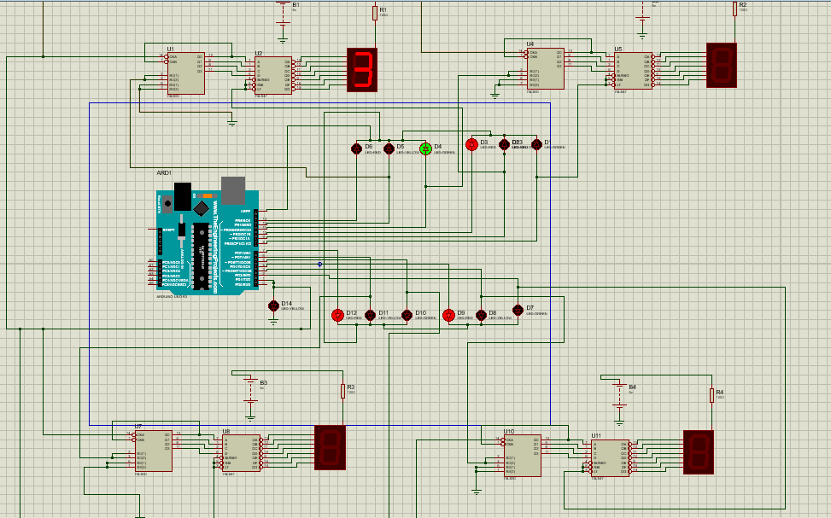

***Components:***

|  |  |  |  |
| --- | --- | --- | --- |
| No. | **Name of Component** | **Specifications** | **Quantity** |
| 1 | Breadboard | - | 2 |
| 2 | Arduino | UNO R3 | 4 |
| 3 | Red LEDs | - | 4 |
| 4 | Yellow LEDs | - | 4 |
| 8 | Green LEDs | - | 4 |
| 9 | Resistor | 470 ohm | 4 |
| 10 | 7 Segment display | Common Anode | 4 |
| 11 | 9V Battery | - | 1 |
| 12 | Connecting Wires | - | - |
| 13 | IC | 74LS90 | 4 |
| 14 | IC | 74LS47 | 4 |

**MODEL CIRCUIT:**

|  |
| --- |
|  |
| LED’s  Arduino UNO R3  9V Battery  74LS90  74LS47  7 Segment Display |

**ADVANTAGES**

Advantages of traffic signals are as follows:

1. Traffic signals help for movement of traffic securely without any collision.

2. They can reduce the number of accidents on roads like pedestrian accident and right-angle collision of two cars.

3. Signals can increase the capacity of traffic handling at the intersection.

4. The traffic signals help for the safe movement of slow-moving traffic by interrupting heavy traffic at regular intervals.

5. The indications of the signals can be seen easily in foggy weather or at night time. Without signaling system, it is very difficult to control traffic by the traffic policeman at night or in foggy weather or on a rainy day.

**Limitations:**

* The project is not suitable for actual implementation but just a demonstration of the process behind the system.
* Real time traffic light controller systems are generally run time programmable i.e. the operator (usually a policeman) can change the timings of each lane as per the intensity of the traffic in each lane.
* There will also be a provision for either manual operation or pre-programmed operation.

**APPLICATIONS:**

* A simple traffic light controller is implemented in this project with a real chance of expansion.
* It can be used on roads where there is any crossing of roads to prevent accidents.

**Possibilities to extend the project with more advanced features:**

This project can be extended more by using sensors, so that it can easily detect that any vehicle is coming and then the signal will automatically turn green from red according to reaching of vehicle to signal. If no vehicle is coming then the signal will remain red.

**REFERENCE:**

https://www.electronicshub.org